**Final Report**

**Project Macallan**

**CIS 5800 FMWA**

**Instructor: Rudy Brown**

**By Team A:**

Maidi Dai (maididai@gmail.com)

Christopher Davis (crdavis0710@gmail.com)

Lakxman Raveendran(lakx94@gmail.com)

Anderson Joaquin (ajoaquin122593@gmail.com)

Alex Alarcon (alexalarcon364@gmail.com)

Gregory Szymanski (gregory.szymanski1@baruchmail.cuny.edu)

**CIS 5800 FMWA**

**Document Information**

|  |  |  |  |
| --- | --- | --- | --- |
| **Section Number** | **Section Title** | **Date Completed** | **Author** |
| A | Cover Page | 05/15/2016 | Maidi Dai |
| B | Table of Contents | 05/15/2016 | Maidi Dai |
| C | Document Information | 05/15/2016 | Anderson Joaquin |
| D | Executive Summary | 05/15/2016 | Lakxman Raveendran |
| E | Prior Deliverables | 05/15/2016 | Christopher Davis |
| F | Test List, Traceability Matrix, WBS | 05/15/2016 | Christopher Davis |
| G | Final Product | 05/15/2016 | Alex Alarcon |
| H | Project Closeout Report | 05/15/2016 | Gregory Szymanski |

|  |  |  |  |
| --- | --- | --- | --- |
| **Project Title:** | Project Macallan | **Impacted Entity:** | Greenpoint Wine and Liquors |
| **Project Team:** | Team A | **Project Sponsor:** | Greenpoint Wine and Liquors |
| **Prepared by:** | Team A | **Date prepared:** | 2/10/2016 |

|  |  |
| --- | --- |
| **Purpose** | Indicate the purpose of this document, and the entity for which the project will be performed. |
| The purpose of this document is to present a problem within an entity and introduce a possible solution. The entity is a retail store that specializes in selling wine and liquor. The name of the business is Greenpoint Wine and Liquors. | |
| **Business Objectives** | Discuss the entity’s overall strategic business objective(s); (e.g. is the general focus on growth, productivity, service, quality, and/or pricing, etc.) |
| The objective of the business is to offer a wide variety of products at a lower than average price. This strategy is possible through bulk purchasing of wine and liquor. | |
| **Problem/Opportunity** | Describe the entity’s current situation, and the reason for the project, stating the problem or business opportunity and why it has to be addressed now. |
| The high amount of products that the manager purchases is stored in a warehouse located a few miles away from the store building. Due to high demand for their products the store requires constant deliveries from its warehouse. The stores workers use a Google spreadsheet to manage the warehouse inventory. The store employees use the spreadsheet to order new cases of liquor for the store. The warehouse employees use the spreadsheet to view the orders from the store. The managers populates the spreadsheet with data manually using the information from the invoices. The spreadsheet is a very inefficient way of managing inventory levels at a company that sells hundreds of different brands of wine and liquors. It is easy for workers to make mistakes while requesting new items. The spreadsheet has limited capacity which soon might cause problems with performance. The manager wishes to have an inventory database that would let him enter information, store it in a more organized fashion and also search for answers related to inventory levels. | |
| **Solution** | Outline the proposed solution to address the entity’s problem/opportunity. |
| * The solution is to create a website application that will consist of a proper relational database and an interface enabling entering and deleting data. This will create a more accurate ability to exchange information between the warehouse and the store about which products are required at the store. | |
| **Benefits** | State how the project will benefit the entity’s overall business objective. |
| * More optimized database management system will allow employees manage a more diverse inventory. Thanks to this the store will be able to offer its customers a bigger range of products. * Thanks to the website employees will be able to order more items in less time and more accurately. The saved time can be then spent on other duties like customer service. | |

|  |  |
| --- | --- |
| **Proposal Contributor** | **Stakeholder (Project Team Member) Name** |
|  | Maidi Dai |
| Christopher Davis |
| Lakxman Raveendran |
| Anderson Joaquin |
| Alex Alarcon |
| Gregory Szymanski |

|  |  |  |  |
| --- | --- | --- | --- |
| **Project Title:** | Project Macallan | **Project Start Date:** | 02/24/2016 |
| **Project Team:** | Team A | **Projected End Date:** | 05/15/2016 |
| **Charter Prepared by:** | Team A | **Date prepared:** | 02/22/2016 |

|  |  |  |
| --- | --- | --- |
| **Topic** | **Description** | **Charters** |
| **Project Purpose** | Describe reason for project, stating problem/opportunity in non-technical terms. | Greenpoint Wine and Liquors is a family owned retail store that specializes in selling a variety of wine and liquors for a discounted price. The company owns a warehouse where they hold the company’s surplus inventory. To manage their stock, the manager and other workers use a Google Spreadsheet. The manager would like to upgrade their system to enhance the functionality of the database. This would allow the manager to make more informed decisions involving inventory. The database will also provide a more comfortable and seamless way of working with the stock. |
| **Project Objectives** | Identify at least two (2) project objectives using SMART criteria (Specific, Measurable, Attainable, Relevant, Time framed) | The project goal is to create a web inventory tracking system.  Project Objectives:   1. Develop a web application backed by a relational database that:  * Allows the user to create, retrieve, update and delete records. * Allows the use of forms to order items. * Generates reports. * Provides reliable security with user privileges and password protection. * Provides a channel for communication between the store and the warehouse. * Allows the manager to view historical inventory data.  1. The project will go into production fully tested and functioning. 2. Complete the project by May 15, 2016. |
| **Scope Summary** | Brief summary outlining the scope of work to be delivered for the project solution. | * High-level scope of work: * Design, develop, implement and test the web application * Design, develop, implement and test the relational database. * Design, implement and test the backend of the application. * Design, develop, implement and test the frontend user interface. * Prepare documentation for: * Project Management Plan * Project Documents * Designs * Any other required deliverable * High-level Requirements include: * A front-end menu interface * Forms for data entry and capture * Reports presenting inventory levels * Reports presenting historical data * Data Warehouse |
| **Assumptions & Constraints** | Outline major assumptions (factors believed to be true), and constraints (limitations that might impact the project). | Assumptions:   * The organization has internet access.   Constraints:   * Due to limited time, we may not be able to implement all the features and may have to exclude some less vital features of the project |
| **Project Impact** | Identify how the project will impact the entity and stakeholders. | 1. The new application will allow the manager of Greenpoint Wine and Liquors faster and more efficient data entry and retrieval. 2. Will provide the manager with a possibility to store and analyze historical data from previous time periods. 3. The application will help workers communicate more effectively between store and warehouse. 4. The application will offer a more transparent and intuitive way of ordering products. 5. The manager will have more control over who has access to the database and how they will use it. |

|  |  |  |
| --- | --- | --- |
| **Project Team** | **Role/Responsibilities** | **Stakeholder (Project Team Member) Name** |
| List roles needed for the project, and the proposed team member(s) performing the role. | Project Sponsor | Michael Buda, manager of Greenpoint W&L |
|  |  |
| Business Analysis | Gregory Szymanski |
| Database Developer | Christopher Davis, Lakxman Raveendran, Anderson Joaquin |
| Application Developer | Alex Alarcon, Maidi Dai |
|  |  |

**Project Management Plan**

**Project Macallan**

**CIS 5800 FMWA**

**Instructor: Rudy Brown**

**By Team A:**

Maidi Dai (maididai@gmail.com)

Christopher Davis (crdavis0710@gmail.com)

Lakxman Raveendran(lakx94@gmail.com)

Anderson Joaquin (ajoaquin122593@gmail.com)

Alex Alarcon (alexalarcon364@gmail.com)

Gregory Szymanski (gregory.szymanski1@baruchmail.cuny.edu)

**CIS 5800 FMWA**

Table of Contents

Introduction 3

Technical Approach 4

Project Life Cycle Model: 4

Tool/Techniques: 5

Subsidiary Plans 5

Requirements Management Plan 5

Human Resource Management and Staffing Plan 5

Communications Management Plan 6

Escalation Process 6

Procurement Management Plan 6

Stakeholder Management Plan: 7

|  |  |  |  |
| --- | --- | --- | --- |
| **Section Number** | **Section Title** | **Date Completed** | **Author** |
| A, B, C | Cover Page, Table of Contents, Document Information | 03/11/2016 | Gregory Szymanski |
| D | Introduction | 03/11/2016 | Anderson Joaquin |
| E | Organizational Management | 03/11/2016 | Maidi Dai |
| F | Technical Approach | 03/11/2016 | Alex Alarcon |
| G | Subsidiary Plans | 03/11/2016 | Lakxman Raveendran |
| G | Subsidiary Plans | 03/11/2016 | Christopher Davis |
|  |  |  |  |

# Introduction

Greenpoint Wine and Liquors is a family run retail store that specializes in selling a variety of wine and liquors for a discount price. Prices range from $10 to $35 per bottle. The organization is brick and mortar store that has an accompanying warehouse. The organization is in control by the owner Ted Tedious and the main manager Michael Buda. Ted’s three sons, Mike, Nick, and Steve run day to day operations managing different aspects of the company. Mike runs the store front and leads a team of 10 people. Nick is the marketing manager and focuses his efforts into trying to promote their product to vendors and other retailers in an effort to form strategic alliances. Steve manages the warehouse with his team consisting of 8 people while organizing and scheduling deliveries to and from the warehouse.

Objectives of Greenpoint Wine and Liquors include developing strong relationships with their suppliers to help insure best discount deals and best supplier services obtainable. Maintaining customer loyalty by insuring products are readily available and promote multiple purchases through a loyalty program. The current project expands upon these goals by upgrading their system to enhance the functionality of the database. This would allow the manager to make more informed decisions involving inventory. Greenpoint’s long term goals include extending market penetration beyond the local Brooklyn area by either opening a new store location or potentially through direct catalog sales or website.

Assumptions of the project include that the organization has internet access. The major constraint of this project is the time frame. Due to limited time, we may not be able to implement all the features and may have to exclude some less vital features of the project.

Organizational Chart

# Technical Approach

## Project Life Cycle Model:

* 1. We will be utilizing a Predictive (Waterfall) Life cycle approach. The phases to the model are broken down as such:
     1. Requirement Analysis: all requirements needed to develop the solution will be gathered and documented.
     2. System Design: based on the requirements gathered and analyzed we will design the solution using UML.
     3. Implementation: based on the design of the system we will implement the solution by making a custom web application.
     4. Testing: we will be continuously test the system based on the requirements as we design and implement.
     5. Deployment: the system will be deployed onto a custom website.
     6. Maintenance: we will resolve any issues that arise while the system is in the client’s environment.

## Tool/Techniques:

Back End:

* Scala with Play Framework:
* PostgreSQL database
* Heroku Cloud server

Front End:

* HTML, CSS, JavaScript (jQuery/Ajax)

# Subsidiary Plans

## Requirements Management Plan

**Indicate how the team will determine and prioritize requirements:**

We will first determine what the main functions are that are required to have a minimum viable product that will function properly and can be used by the business. We will prioritize those functions over all other requirements. After we have a minimum viable product, we will work to get the additional functions that are not exactly needed will be helpful and make the manager’s job much easier to make new orders for the suppliers.

## 

## Human Resource Management and Staffing Plan

**Indicate if the team will need to learn new technologies for the project:**

The team members responsible for implementing the product don’t require additional training.

## Communications Management Plan

**List all Methods or Tools the team will use to communicate**

We are using Google Drive to share documents between our group so that we know what each person is doing. We are using a group messaging application, GroupMe, to be able to communicate with everyone easily. We are also meeting when necessary to make decisions or see what our next step will be in our project.

**Indicate the time frame and frequency of communication**

With Google Drive and GroupMe, we are able to communicate with each other any time that any of us have an issue or something that needs to be brought up to the team. We also are able to talk with our group before and after class for any same problems we may have. We will also have weekly or bi-weekly to discuss bigger issues or to see where we are in our project and assign new tasks to each other.

# Escalation Process

1. As issues arise, the need for real-time stock levels is critical. Based off the inventory timed refresh rate, an order can be placed but not fulfilled because the refresh time does not reflect the real time inventory levels.
2. The supplier will now reach out to the manufacturer or his distributor to escalate a priority shipment of the product to the liquor store to satisfy the order that was placed.

# Procurement Management Plan

No specific software will be acquired for this project.

# Stakeholder Management Plan:

|  |  |  |
| --- | --- | --- |
| **Name** | **Position** | **Internal/External** |
| **Julio Jenkins** | Customer | External |
| **Empire** | Supplier | External |
| **Name** | **Position** | **Internal/External** |
| **Michael Buda** | Manager | Internal |
| **Ted Tedious** | Owner | Internal |

**Analysis & Design**

**Project Macallan**

**CIS 5800 FMWA**

**Instructor: Rudy Brown**

**Team A:**

Maidi Dai (maididai@gmail.com)

Christopher Davis (crdavis0710@gmail.com)

Lakxman Raveendran (lakx94@gmail.com)

Anderson Joaquin (ajoaquin122593@gmail.com)

Alex Alarcon (alexalarcon364@gmail.com)

Gregory Szymanski ([gregory.szymanski1@baruchmail.cuny.edu](mailto:gregory.szymanski1@baruchmail.cuny.edu))

**CIS 5800 FMWA**

Contents

Document Information 2

Executive Summary 3

Requirements 4

Use Case Model 4

List of Use Cases and their codes: 5

Requirements Traceability Matrix 7

Class Diagram Modeling 9

Activity Diagram 10

Sequence Diagram 11

Database Model 12

Data Dictionary 13

Test List 15

# Document Information

|  |  |  |  |
| --- | --- | --- | --- |
| **Section Number** | **Section Title** | **Date Completed** | **Author** |
| A | Cover Page | 1/23/2016 | Maidi Dai |
| B | Table of Contents | 1/23/2016 | Maidi Dai |
| C | Document Information | 1/23/2016 | Lakxman Raveendran |
| D | Executive Summary | 1/23/2016 | Lakxman Raveendran |
| E | Requirements | 1/23/2016 | Alex Alarcon |
| F | Use Case Diagram | 1/23/2016 | Gregory Szymanski |
| G | Requirements Traceability Matrix | 1/23/2016 | Gregory Szymanski |
| H | Class Diagram Modeling | 1/23/2016 | Alex Alarcon |
| I | UML Diagramming | 1/23/2016 | Anderson Joaquin |
| J | Database Model | 1/23/2016 | Gregory Szymanski |
| K | Test List | 1/23/2016 | Christopher Davis |

# Executive Summary

Greenpoint Wine & Liquors has undergone the decision to change their inventory management system for a variety of reasons. Currently, Greenpoint Wine and Liquors is using invoice documents from distributors as the main source of information to populate their Google spreadsheet. As of now employees login using the same account and password. There are no specific privileges for the type of employee accessing the data. The store workers manually prepare a list of items that need to be ordered at the store. The store also has a backroom which hold inventory not shelved. They store this information on where specifically the item should be placed within the store into the Google spreadsheet. For example an item could go straight to the front end of the store as a main priority or be placed in the backroom as storage or surplus. These are the types of problems they face on a daily basis.

Greenpoint Wine & Liquors is looking to have the inventory system assist the managers and employees to make better business decisions. These decisions range from looking over historical data conductive to analyzing trends to making better forecasts through a user friendly interface. The system will also have added security such as user permissions and the functionality to perform specific queries. The information that will outlined in this document include requirements of the new database to be implemented and UML diagrams outlining the specific attributes and functions of systems, actors and actions. This document will also entail database modeling, traceability matrix and test lists to track the validation of software functions.

# Requirements

R1 – Manager should be able to create new users.

R2 - User should be able to log in.

R3 – Manager should be able to enter new products to the database.

R4 – User should be able to view the list of available items at the warehouse.

R5 – Store employee should be able to order new items to be delivered from the warehouse to the store.

R6 – Warehouse employee should be able to give a notification that the ordered item has been picked out.

R7 – Warehouse employee that finds a missing item at the warehouse that is not in the database should be able to enter that item to a list of items found.

R8 – Warehouse employee should be able to view a purchase orders list of items that are planned to be delivered to the warehouse.

R9 – Store employee should be able to view inventory of the store cellar.

R10 – Manager should be able to view data about inventory from previous time periods.

# Use Case Model

## List of Use Cases and their codes:

UC1 – Create new user.

UC2 – Log in.

UC3 – Enter new item.

UC4 – Update records

UC5 – View inventory.

UC6 – Order an item.

UC7 – Write off an item.

UC8 – Add to lost and found item list.

UC9 – View purchase order list.

UC10 – View cellar list.

UC11 – View historical data.

Use Case Diagram

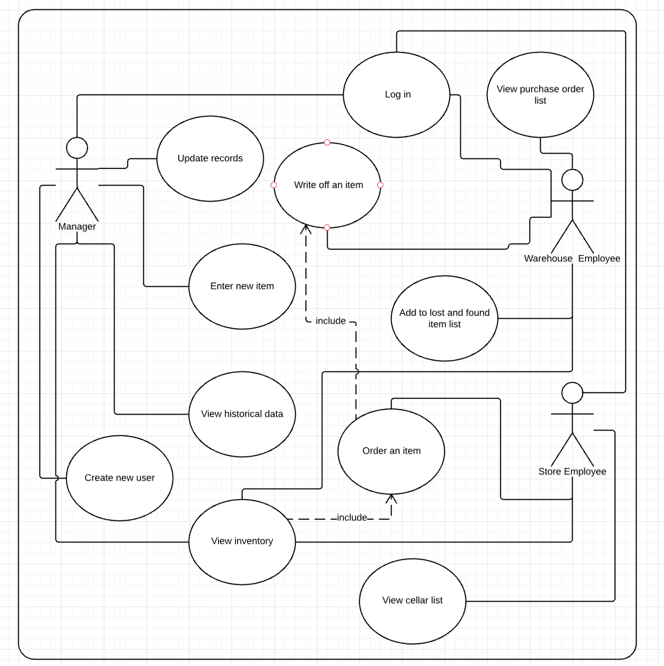

# Requirements Traceability Matrix

|  |  |  |  |  |  |  |  |  |  |
| --- | --- | --- | --- | --- | --- | --- | --- | --- | --- |
| **Req ID** | **Requirement Name** | **Use Case ID** | **Use Case Name** | **Priority** | **Complexity** | **Test ID** | **Implemented (Y/N)** | **Date Completed** | **Owner** |
| R1 | Manager should be able to create new users. | UC1 | Create new user. | High | Complex | T1 | Y |  |  |
| R2 | User should be able to log in. | UC2 | Log in. | High | Complex | T2 | Y |  |  |
| R3 | Manager should be able to enter new products to the database. | UC3 | Enter new item. | High | Simple | T3 | Y |  |  |
| R4 | Manager has the ability to update information about an item. | UC4 | Update records. | High | Simple | T4 | Y |  |  |
| R5 | User should be able to view the list of available items at the warehouse. | UC5 | View inventory. | High | Simple | T5 | Y |  |  |
| R6 | Store employee should be able to order new items to be delivered from the warehouse to the store. | UC6 | Order an item. | High | Simple | T6 | Y |  |  |
| R7 | Warehouse employee should be able to give a notification that the ordered item has been picked out. | UC7 | Write off an item. | High | Moderate | T7 | Y |  |  |
| R8 | Warehouse employee that finds a missing item at the warehouse that is not in the database should be able to enter that item to a list of items found. | UC8 | Add to lost and found item list. | Medium | Moderate | T8 | N |  |  |
| R9 | Warehouse employee should be able to view a purchase orders list of items that are planned to be delivered to the warehouse. | UC10 | View purchase order list. | Low | Moderate | T9 | N |  |  |
| R10 | Store employee should be able to view inventory of the store cellar. | UC11 | View cellar list. | Medium | Moderate | T10 | N |  |  |
| R11 | Manager should be able to view data about inventory from previous time periods. | UC12 | View historical data. | Low | Complex | T11 | N |  |  |

# Class Diagram Modeling

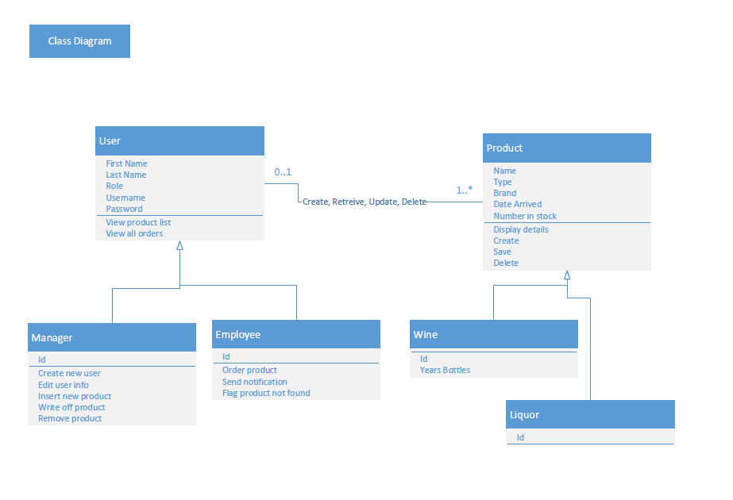

# Activity Diagram

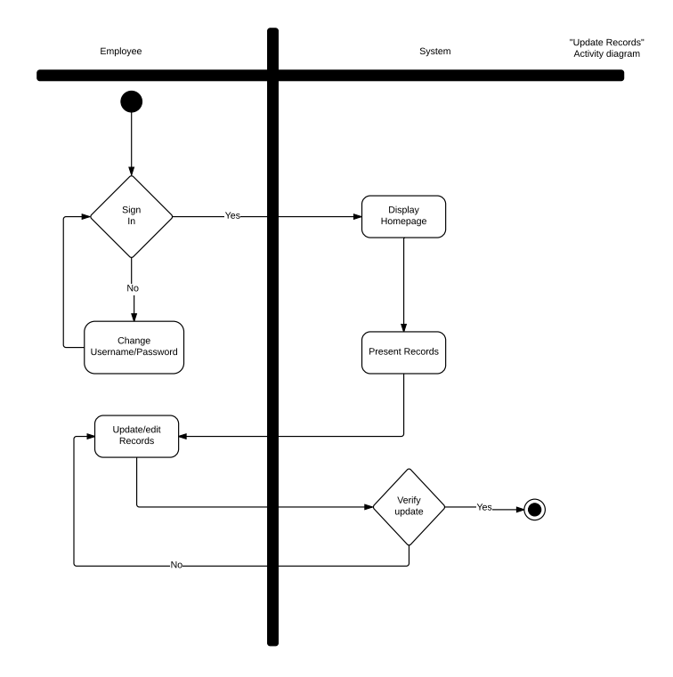

# Sequence Diagram

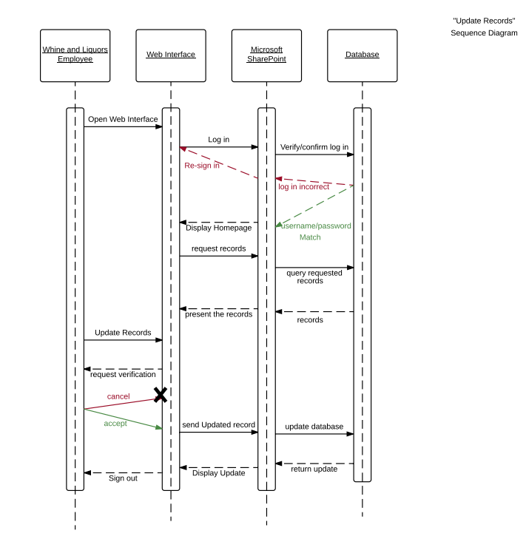

# Database Model

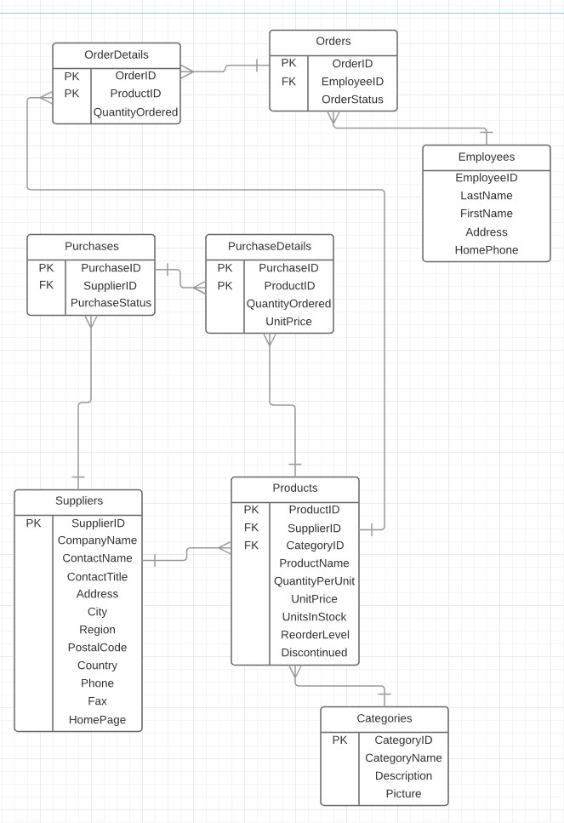

## Data Dictionary

|  |  |  |  |  |  |
| --- | --- | --- | --- | --- | --- |
| Table Name | Field Name | Field Length | Data Type | Primary Key | Foreign Key |
|  |  |  |  |  |  |
| Products | ProductID | Long Integer | AutoNumber | Yes | No |
|  | SupplierID | Long Integer | Number | No | Yes |
|  | CategoryID | Long Integer | Number | No | Yes |
|  | ProductName | 40 | Short Text | No | No |
|  | QuantityPerUnit | 40 | Short Text | No | No |
|  | UnitPrice | 8 | Currency | No | No |
|  | UnitsInStock | Long Integer | Number | No | No |
|  | ReorderLevel | Long Integer | Number | No | No |
|  | Discontinued | 1 | Boolean | No | No |
|  |  |  |  |  |  |
| Categories | CategoryID | Long Integer | AutoNumber | Yes | No |
|  | CategoryName | 40 | Short Text | No | No |
|  | Description | 40 | Long Text | No | No |
|  | Picture | Attachment | OLE Object | No | No |
|  |  |  |  |  |  |
| Suppliers | SupplierID | Long Integer | AutoNumber | Yes | No |
|  | CompanyName | 40 | ShortText | No | No |
|  | ContactName | 40 | ShortText | No | No |
|  | ContactTitle | 40 | ShortText | No | No |
|  | Address | 40 | ShortText | No | No |
|  | City | 40 | ShortText | No | No |
|  | Region | 40 | ShortText | No | No |
|  | PostalCode | 40 | ShortText | No | No |
|  | Country | 40 | ShortText | No | No |
|  | Phone | 40 | ShortText | No | No |
|  | Fax | 40 | ShortText | No | No |
|  | HomePage |  | Hyperlink | No | No |
|  |  |  |  |  |  |
| Purchases | PurchaseID | Long Integer | Number | Yes | No |
|  | SupplierID | Long Integer | Number | No | Yes |
|  | PurchaseStatus | 1 | Boolean | No | Yes |
|  |  |  |  |  |  |
| PurchaseDetails | PurchaseID | Long Integer | Number | Yes | No |
|  | ProductID | Long Integer | Number | Yes | No |
|  | QuantityOrdered | Long Integer | Number | Yes | No |
|  | UnitPrice | 8 | Currency | No | No |
|  |  |  |  |  |  |
| Orders | OrderID | Long Integer | AutoNumber | Yes | No |
|  | EmployeeID | 40 | Short Text | No | No |
|  | OrderStatus | 1 | Boolean | No | No |
|  |  |  |  |  |  |
| OrderDetails | OrderID | Long Integer | Number | Yes | No |
|  | ProductID | Long Integer | Number | Yes | No |
|  | QuantityOrdered | Long Integer | Number | No | No |
|  |  |  |  |  |  |
| Employees | EmployeeID | Long Integer | AutoNumber | Yes | No |
|  | LastName | 40 | Short Text | No | No |
|  | FirstName | 40 | Short Text | No | No |
|  | Address | 40 | Short Text | No | No |
|  | HomePhone | 40 | Short Text | No | No |

# Test List

|  |  |  |  |  |  |
| --- | --- | --- | --- | --- | --- |
| **Test ID** | **Test Name** | **Test Description** | **Tester** | **Test Date** | **Test Status (Pass/Fail/Not Tested)** |
| TC1 | Web Interface Opens | Sequence Diagram | Alex Alarcon | 04/30/16 | Pass |
| TC2 | Homepage Displays | Activity Diagram | Maidi Dai | 04/30/16 | Pass |
| TC3 | Worker Access to the Website | Activity Diagram | Gregory Szymanski | 04/30/16 | Pass |
| TC4 | Records Display | Activity Diagram | Alex Alarcon | 05/3/16 | Pass |
| TC5 | Update/Edit Records | Activity Diagram | Christopher Davis | 04/3/16 | Pass |
| TC6 | Verify Updates | Activity Diagram | Christopher Davis | 04/3/16 | Pass |
| TC7 | Save Updates | Sequence Diagram | Lakxman Raveendran | 04/3/16 | Pass |

**Technical Design & Implementation**

**Project Macallan**

**CIS 5800 FMWA**

**Instructor: Rudy Brown**

**Team A:**

Maidi Dai (maididai@gmail.com)

Christopher Davis (crdavis0710@gmail.com)

Lakxman Raveendran (lakx94@gmail.com)

Anderson Joaquin (ajoaquin122593@gmail.com)

Alex Alarcon (alexalarcon364@gmail.com)

Gregory Szymanski (gregory.szymanski1@baruchmail.cuny.edu)

CIS 5800 FMWA

Contents

Document Information 3

Executive Summary 4

Menu Structure 5

User Interface Design 6

Query Design 7

Report Design 8

Hardware/Software 9

Implementation Plan 10

Training Plan 11

Support Plan 12

# Document Information

|  |  |  |  |
| --- | --- | --- | --- |
| **Section Number** | **Section Title** | **Date Completed** | **Author** |
| 1 | Executive Summary | 4/18/16 | Christopher Davis |
| 2 | Menu Structure | 4/18/16 | Maidi Dai |
| 3 | User Interface | 4/18/16 | Maidi Dai |
| 4 | Query Design | 4/18/16 | Alex Alarcon |
| 5 | External Interface | 4/18/16 | Alex Alarcon |
| 6 | Report Design | 4/18/16 | Alex Alarcon |
| 7 | Implementation Hardware/Software | 4/18/16 | Christopher Davis |
| 8 | Implementation Plan | 4/18/16 | Lakxman Raveendran |
| 9 | Training Plan | 4/18/16 | Anderson Joaquin |
| 10 | Support Plan | 4/18/16 | Anderson Joaquin |
| 11 | MS Project Plan Add/Update | 4/18/16 | Gregory Szymanski |

# Executive Summary

GreenPoint Wine and Liquors has undergone the decision to change their inventory management system for a variety of reasons. Currently, GreenPoint Wine and Liquors is using invoice documents from distributors as the main source of information to populate their Google spreadsheet. As of now, employees login using the same account and password. There are no specific privileges for the type of employee accessing the data. The store workers manually prepare a list of items that need to be ordered at the store. The store also has a backroom which hold inventory not shelved. They store this information on where specifically the item should be placed within the store into the Google spreadsheet. For example, an item could go straight to the front end of the store as a main priority or be placed in the backroom as storage or surplus. These are the types of problems they face on a daily basis.

GreenPoint Wine and Liquors is looking to have the inventory system assist the managers and employees to make better business decisions. These decisions range from looking over historical data conducive to analyzing trends to making better forecasts through a user friendly interface. The system will also have added security such as user permissions and the functionality to perform specific queries. The information that will be outlined in this document include the technical design structure the database will implement such as the menu structure, user interface design, query design, and screenshots of the multiple interfaces. The document will also entail an implementation aspect which will include the following Commercial Off-The-Shelf component, an implementation plan, a training plan, and finally, a support plan.

# Menu Structure



# User Interface Design

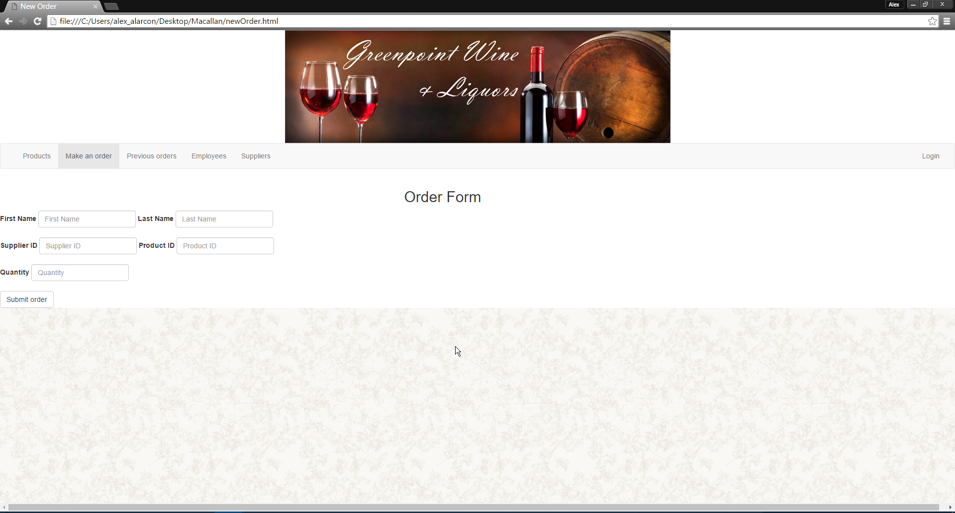

# Query Design

*Query design used with the assistance of Slick for Play Framework

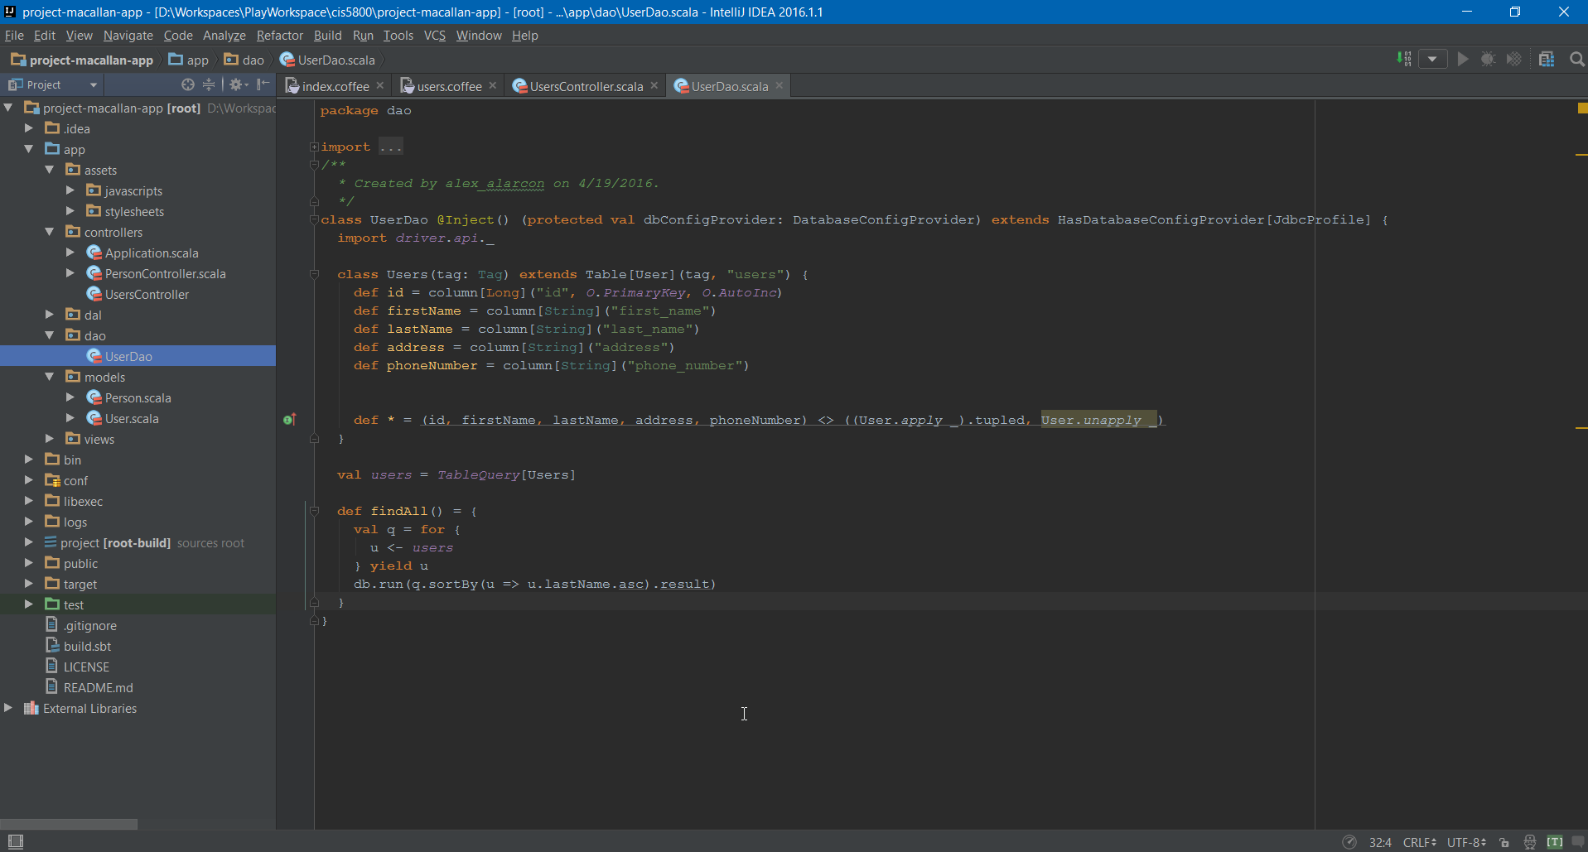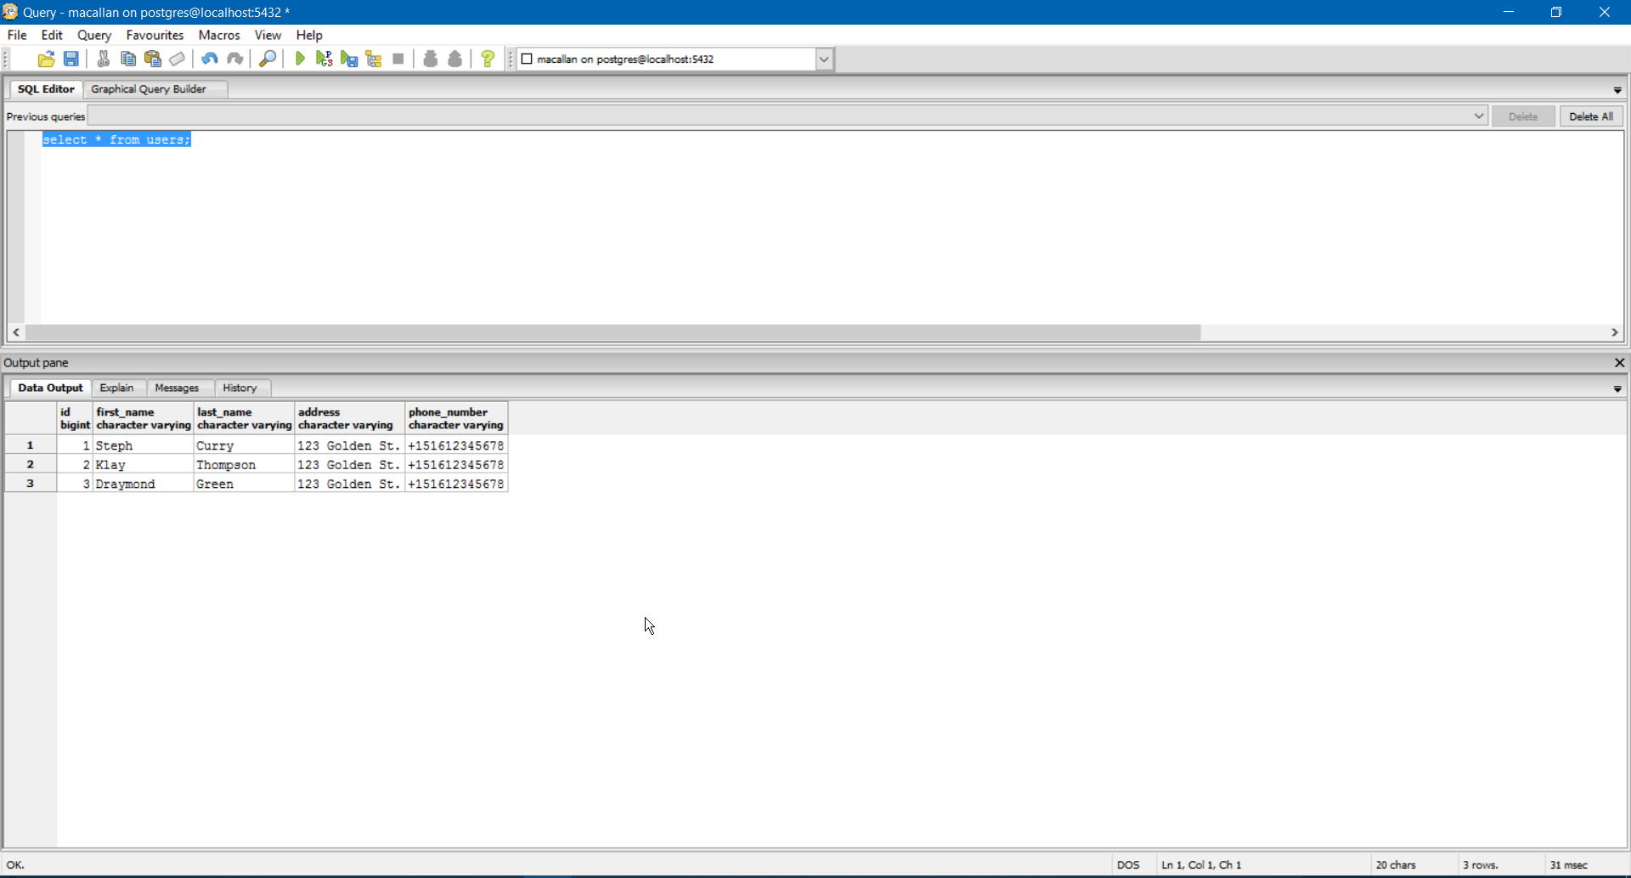

# Report Design

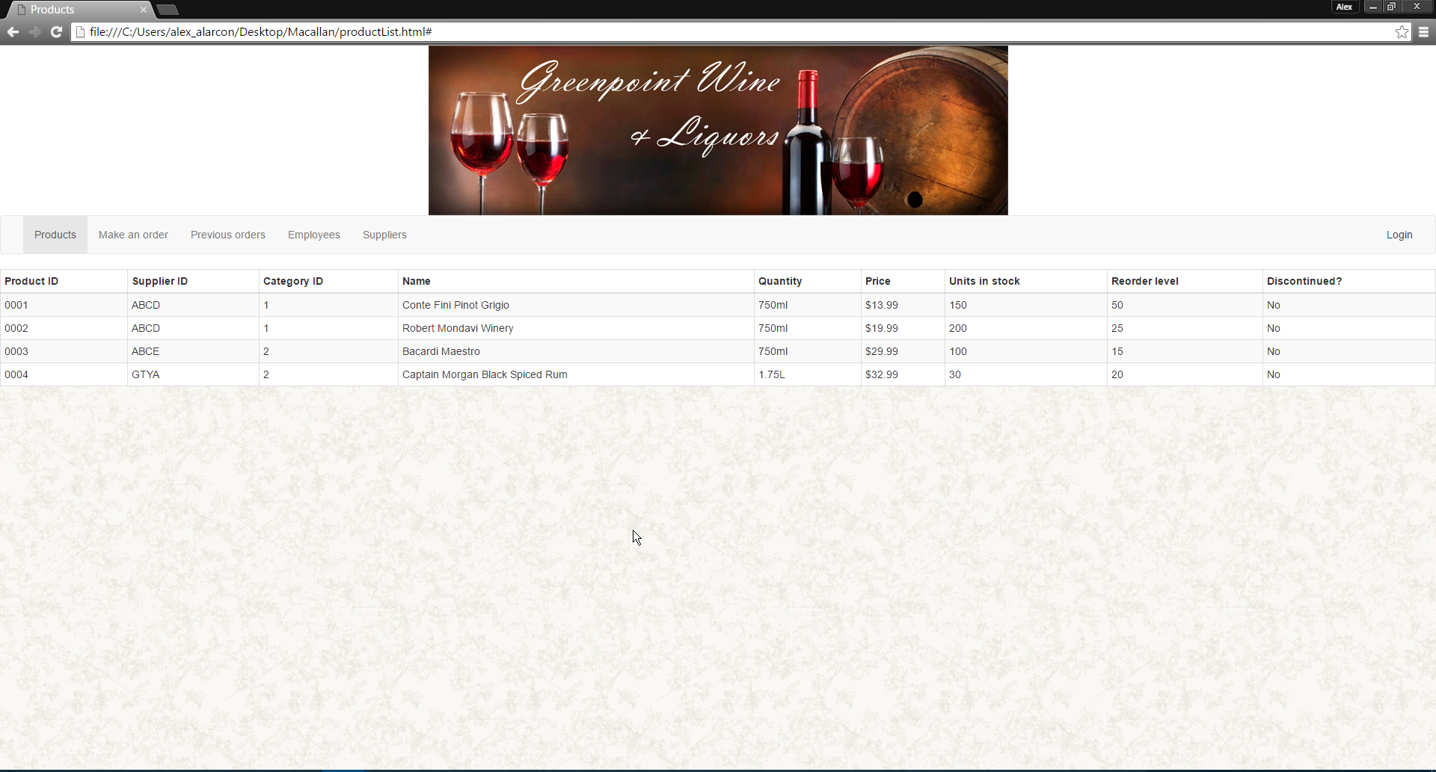

# Hardware/Software

Commercial Off-The-Shelf Components GreenPoint Wine and Liquors require:

**Hardware:**

* 2x Workstation Computers - $1,750.00/ea
* 4x 23’ inch Widescreen Monitors - $350/ea
* 2x Barcode Scanner - $150/ea

**Software:**

**Network:**

* Verizon FiOS - $169.99/mo

# Implementation Plan

High Level Deployment Diagram

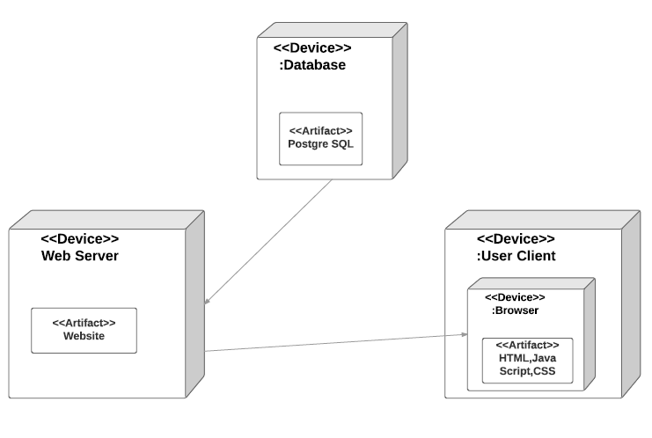

The criteria that will be used to determine when the system will "Go Live" consists of testing of the system to make sure all stated functionality and design is working properly at all times.  All hardware, software, and interfacing should pass testing for any networking, connectivity or compatibility issues. Data backup procedures should also be checked as well as authentication processes for each type of user. Prior to "going live" the staff will be have to be trained and must be accommodated to the system.

The application will be rolled out at one time with both front store and warehouse employees being able to use the system at the same time. Stakeholders inside of the company will be informed by a company-wide email in addition to the information provided during meetings and training sessions. External stakeholders such as customers will be informed through social media and weekly newsletters that Greenpoint Wine and Liquors sends out. Suppliers will be sent an email informing them of the system change.

# Training Plan

In order to get the employees at the Green Point Whine and Liquors store up to date with the new inventory system there will need to be at least two person to person training. The first session would provide the employees with an introduction to the apps interface while helping them create user profiles. In the second session the priority would be to get the employees to get there hands dirty, in order to do this we will present the employees with practice scenarios to make sure that they feel comfortable with the app. The end goal being that they can successfully input and record transactions while feeling confident using the application. After the two mandatory in person sessions we will maintain the staff available for the whole week in order to accommodate those who cannot find the time to attend the two general days.

# Support Plan

Online support would be provided via email. These issues will be taken care of in chronological order, meaning first come first serve*. In order to resolve issues in a timely manner we will create a form which the person having issues fills out (ticket), this ticket is what would be attached to the body of the email. The ticket would generate a case number to be shown to the customer in order for the person to keep track on what stage their ticket is on. To request a ticket form please visit WWW.GREENPOINTLIQUORS.com/SUPPORT

*Response times depending on whether the issue affects the whole network (ex: server down) or a single user/ high risk problems would be pushed forward.

|  |  |  |  |
| --- | --- | --- | --- |
| **Project Title:** | Project Macallan | **Project Start Date:** | 03/11/2016 |
| **Project Team:** | Team A | **Projected End Date:** | 05/15/2016 |
| **Prepared by:** | Gregory Szymanski | **Date prepared:** | 05/15/2016 |

|  |  |  |
| --- | --- | --- |
| **Objectives** | | |
| Project Objectives | Met/Not Met | Explanation (why Met/Not Met) |
| Allows the user to create, retrieve, update and delete records. | Met |  |
| Allows the use of forms to order items. | Met |  |
| Generates reports. | Met |  |
| Allows the manager to view historical inventory data. | Not Met |  |
| Provides reliable security with user privileges and password protection. | Met | We created a login window that requires a user to enter his name and password. |
|  |  |  |

|  |  |  |  |
| --- | --- | --- | --- |
| **Schedule Objectives (Duration from MS Project Plan/WBS)** | | | |
| Planned | Actual | Variance | Explanation (why Met/Not Met) |
| 57 | 46 | -11 | We were able to complete the project before the planned time thanks to some scope adjustments and change of tools and skills we planned to use for this project. |

|  |  |  |  |
| --- | --- | --- | --- |
| **Budget Objectives (Total Cost $ from MS Project Plan/WBS)** | | | |
| Planned | Actual | Variance | Explanation (why Met/Not Met) |
| 0 | 0 | 0 | No budget was required for this project. |

|  |  |  |
| --- | --- | --- |
| **Product Acceptance** | | |
| Acceptance Criteria | Met/Not Met | Explanation (why Met/Not Met) |
| 50% of requirements is developed | Met | The team was able to create:  - A front-end menu interface.  - Forms for data entry and capture.  What was not achieved is:    - Reports presenting inventory levels.  - Reports presenting historical data. |
| 50% of the product is tested | Met | Each of our product feature that is available in our web app was tested. |
| 50% of test cases pass | Met | Features that got to the testing phase passed it. |
| 50% of product performs as expected | Met | All the implemented features work as planned. |
| The software is fully developed by project team, with the exception of one approved complex function/feature | Not met | Beside implementing a Data Warehouse we were not able to add a reports. This makes it more than one function/feature missing. |

|  |  |  |
| --- | --- | --- |
| **Overall Project Success** | | |
| Success Criteria | Met/Not Met | Explanation (why Met/Not Met) |
| 50% of Project Objectives are met | Met | The most important objective was achieved. We provided an improved way of information exchange between the store and warehouse. Employee can use the system to quickly order items from the warehouse that are needed at the store. |
| Green or Yellow Overall Project Status | Yellow |  |

|  |
| --- |
| **Major Scope Changes** |
| * + - Describe any major change from original plan, requirements, design, etc.     - Explain why there was a major change (if any) |
| The team decided not to use Microsoft Access and SharePoint for this project. Due to the lack of experience in using these tools the team decided it prefers to create its web application instead.  The team had to give up the idea of making a Data Warehouse that would allow the manager analyze historical data. This feature was already low on our priority list and we decided that it is better to make sure that other features are ready for deployment. |

|  |
| --- |
| **Proposed Future Modifications** |
| * + - List any additional/future modification recommended |
| * Reports * Data Warehouse * Cellar list ( List of products that are in the stores basement.) * Purchase forms (possibility to order items from companies supplying the store) |

|  |
| --- |
| **Lessons Learned** |
| * + - Describe the project area(s) that the team did well     - Describe the project area(s) that the team did not do as well     - Describe any take away and/or feedback of working on the project     - What would be done different if placed on another similar project |
| The level of communication between team members was good. The team was always able to divide the work accordingly. This allowed the group to deliver documentation and other important parts of the project on time. |